- Purpose: These Standard operating procedures are set to guide the workflow and process of Global event-based surveillance to allow for early detection and response.

- Apply to: Syndromic Surveillance departments, Executive Department of Surveillance

- Definitions:
Epidemic Intelligence | EI
Epidemic Intelligence from Open Sources (EIOS), Portal developed by WHO | EIOS
Refers to countries neighboring the kingdom of Saudi Arabia and/or sharing borders; includes: GCC, Yemen, Iraq, Syria, Jordan, Palestine, Lebanon, Egypt and Sudan. | Regional
Syndromic Surveillance | SS
- Related documents:

- Related forms/Process (If applied)

- Procedures:
Serial | Procedure | Responsible
1 | - PHI Epidemic intelligence activities are handled by Syndromic Surveillance Department. EI Service is supported by the following stakeholders:  - Health Informatics Department  - Global Health Department  - Emergency and preparedness Department
2 | Signal Detection  - Media scanning is an active process performed by the assigned EIOS’s team daily, during workweek (between 09:00 to 10:00 AM) to detect the signals.  - Utilizing EIOS, two boards are be created.  - A Board for Chemical, Radiation and Nuclear Events  - A Board for Biological Events  - Search is conducted using agreed upon keywords (Appendix 1)  - Signals that are captured from media should be recorded in the EIOS Template (Appendix 2)  - Other tools to be utilized include:  - Beacon  - HealthMap  - ProMed  - GPHIN  - Signals That are captured from these sources should be recorded in the “Other Signals” Template” (Appendix 3) | SS
3 | Signal filtration  - Signals that are captured shall be filtered by removing duplicates and information that is not relevant  - Signals shall be reported to EI unit for Triaging. | SS Specialist
4 | Signal Triaging  - Triaging round will be conducted by PHI EIOS team daily.  - Picked up signals shall meet one of the following criteria  - Unknown illness  - Unusual event (antimicrobial resistance, detection of new features of a disease, atypical signs, and symptoms, significantly high number of cases over a short period in a limited geographic area, newly imported disease, occurrence in an area outside the endemic areas in the country)  - The risk to the health system (affects a significant proportion of health workers, Case fatality rate (CFR) of the disease is significantly higher than expected, the occurrence of disease outside the normal seasonal pattern, re-emergence of communicable diseases, affects a conflict area)  - International disease spread  - Interference with travel or trade  - Disease for elimination or eradication  - Zoonotic diseases  - Suspected, accidental or deliberate biological or chemical threats  - Sensational report or high media attention expected | SS Specialist
5 | Second Signal Triaging  - A second triaging process to identify signals of interests.  - Signals triaged at this stage are to be included in the weekly report for stakeholders to review.  - Signals inclusion criteria are:  - Emerging; new pathogen or strain  - Diseases with High CFR; e.g., Haemorrhagic fevers  - Diseases with high publicity (Frequently mentioned)  - Events in neighbouring countries  - Chemical hazards and products that potentially be imported  - Important Respiratory diseases Monitoring | SS Health Expert
6 | Signal Verification  - Communicate with the relevant sector for signal verification.  - follow-up on signals sent for verification until verification is obtained. Signals should be verified within 24 hours of detection. | SS Specialist
7 | Escalation  - Review if any of the verified signals meet the escalation criteria set by Preparedness and response department (Appendix 4).  - Report any signal that requires escalation to Director, Syndromic Surveillance | SS Health Expert
8 | Reports and record keeping  - Weekly report of triaged signals shall be incorporated in PHI weekly report and shared through Tabadul Platform for stakeholders.  - All Signals captured are kept in the PHI shared folder under Syndromic Surveillance EIOS | SS Health Expert

- Monitoring measures:
- Monthly number of Signals that were not captured benchmarked with other agencies including Gulf Center for Diseases Prevention and Control.
- Number of articles screened
- Percentage of Signals that were captured that meet the triaging criteria.
- Percentage of Signals Verified within 24 hours.
- Percentage of Signals that were escalated.

- Related forms (If apply):
- Update history
update | Date
- Signatory

Written by
Name | Position | Signature | Date
Revised by
Name |  | Signature | Date
Recommended by
Name | Chairman of P&P Committee | Signature | Date
Approved by
Name | Sector leader | Signature | Date

Appendix 1 — EIOS Daily Article Screening Strategy
Section | Procedure (Daily Screening)
A. Purpose | Standardize daily EIOS screening for Infectious Disease Surveillance and Environmental Threats Surveillance using consistent boards, filters, categories, and agreed keywords (aligned with epi-week).
1. Access & boards | Open EIOS at: https://eios.who.int/portal/monitoring/boards  Select a board; Use two boards: 1) Infectious Disease Surveillance; 2) Environmental Threats Surveillance.  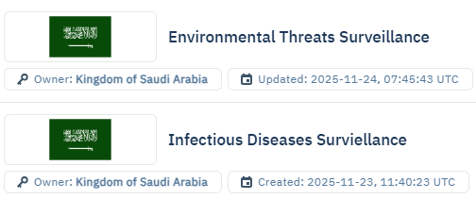
2. Basic filters | Apply baseline filters within the selected board:  Time (previous day or 3 days).  Language (English and/or Arabic) if needed.  Geographical area (When monitoring targeted event is required)  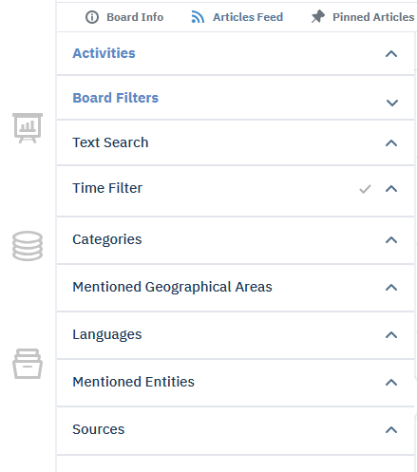
2.1 Time (epi-week aligned) | Epi-week runs Sunday 00:00 to Saturday 23:59.  Daily screening uses previous day only: 00:01–23:59 of the previous calendar day.  Sunday screening covers Thursday 00:01 through Saturday 23:59.  When needed and approved, a process for extra hours may be required. This ensures continuous epi-week coverage without overlap or gaps.
2.2 Language | Select publication language(s): English and/or Arabic (as applicable).
3. Infectious Disease board | 3.1 Category: Categories → Human Health → Human Infectious Disease.  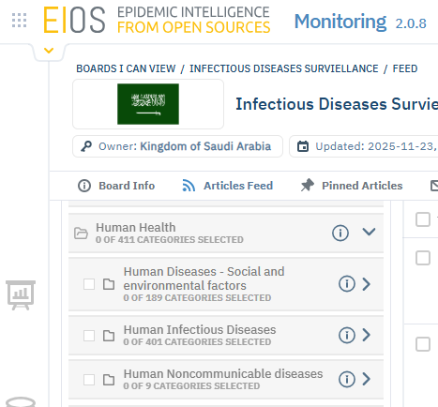  3.2 Browse stream without Text Search keywords.  3.3 Text Search (one keyword per search): Outbreak; Cluster; Epidemic; outbreak; Unusual; Sudden increase; Spike in cases; Mysterious; Mystery/Unknown disease; Mass/Unusual deaths; Hospital overload; Overwhelmed hospitals; Quarantine/Lockdown; surge; Critical; Hospitalized/Admission surge; Death toll/Fatalities rising.  3.4 Disease-specific searches (as needed): Meningococcal meningitis (Neisseria meningitidis); Meningitis (other); COVID-19; Influenza; MERS; Mpox; Dengue; Viral hemorrhagic fevers (e.g., Ebola); Yellow fever; Marburg; AFP/suspected poliomyelitis; Cholera; Foodborne outbreak; Malaria; Measles.
4. Environmental Threats board | 4.1 Select Environmental Threats Surveillance board and apply Time + Language filters.  4.2 Category: Categories → Human Health → Social and environmental factors → environmental or toxic exposures  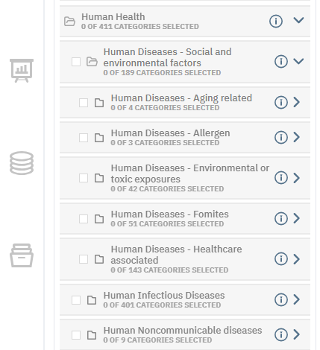  4.3 Category: Categories → CBRN and HAZMAT → CBRN, chemical hazard/event, radio nuclear hazards/event and unknown substances  4.4 Category: Categories → chemicals → all chemicals; unknown substance  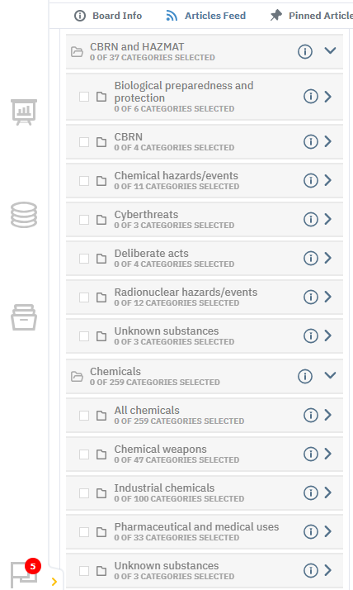  4.5 Category: Categories → environment → natural disasters and pollution  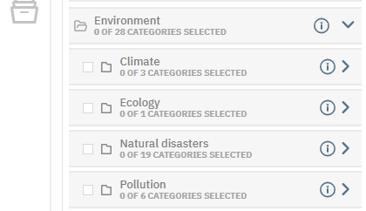  4.6 Browse without Text Search keywords.  4.7 Text Search (one keyword per search): Poisoning; Emergency; risk; disaster; Chemical; Radiation; Nuclear.

